CN Assignment-03

Jeetu Mehra
U24AI032

Question 1 : Construct a star topology in the Cisco packet tracer as shown below, and check where the data packets are transferring from one system to another using ping.
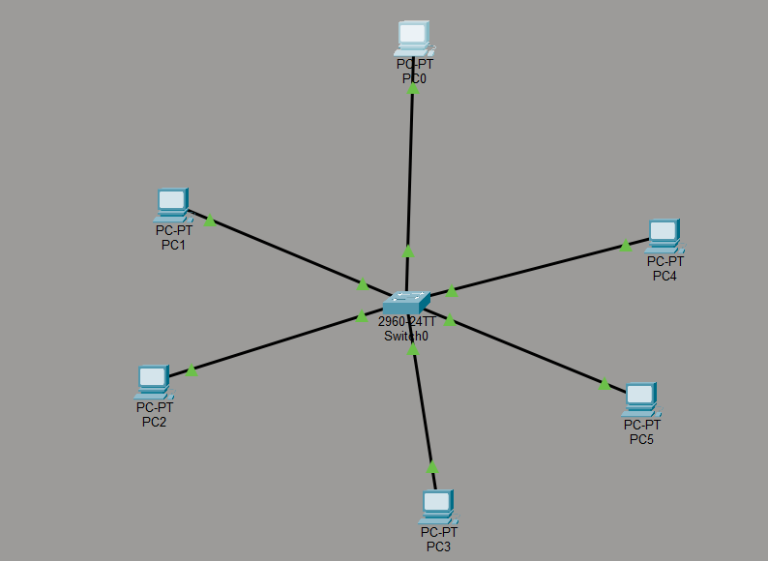
Output:

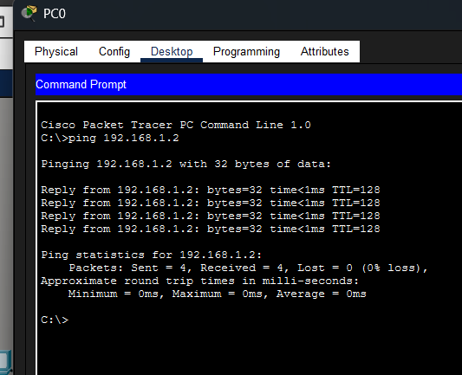

Question 2 : Construct a bus topology in the Cisco packet tracer as shown below, and check where the data packets are transferring from one system to another.
Output:
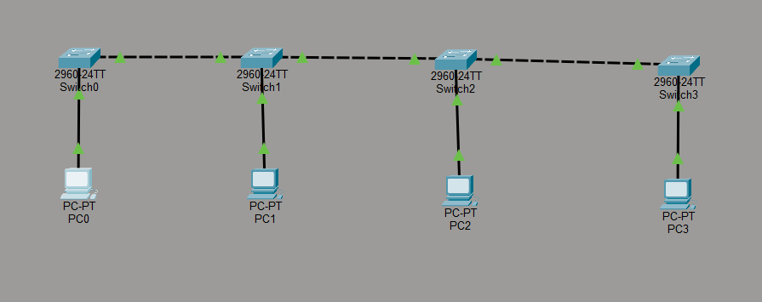

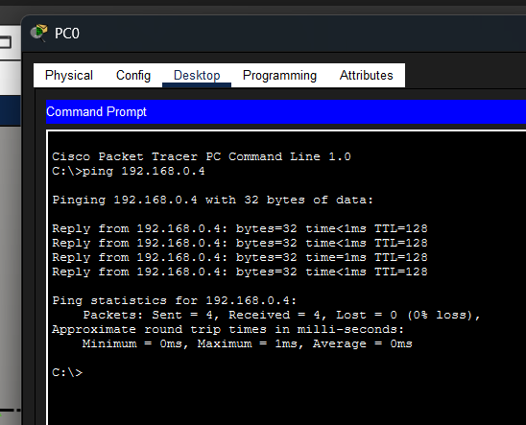

Question 3 : Construct a ring topology in the Cisco packet tracer as shown below, and check where the data packets are transferring from one system to another.
Output:
